DIRBS View v1.0.0

User Guide

DIRBS-View-v1.0.0

Sep 6, 2019

|  |
| --- |
|  |

Revision history

|  |  |  |
| --- | --- | --- |
| Revision | Date | Description |
| A |  | Initial release |

Contents

1. Introduction 5

1.1. Purpose 5

1.2. Supported Desktop Browsers 5

1.3. Definitions, Acronyms, and Abbreviations 6

2. System Description 7

3. System Navigation 9

3.1. Login Screen 9

3.2. Dashboard Overview 10

3.3. Core 15

3.3.1. Range Graphs 15

3.3.2. Monthly Graphs 20

3.4. Device Registration Subsystem 30

3.5. Lost & Stolen Device Subsystem 41

3.6. Device Pairing Subsystem 46

**Figures**

Figure 1-Login Screen 9

Figure 2-Dashboard Screen 10

Figure 3- Core Details 11

Figure 4- DRS Details 12

Figure 5- DPS Details 13

Figure 6- LSDS Details 14

Figure 7-Range Graph 15

Figure 8- Top Model Details 16

Figure 9-Number of IMEIs in Black List 17

Figure 10- Network Operator Exception List Stats 18

Figure 11- Network Operator Notification List Stats 19

Figure 12- Monthly Graph 20

Figure 13- Identifier Counts 21

Figure 14- Compliance Breakdown 22

Figure 15- Identifier Trends 23

Figure 16- Blacklist Violations by Days Post Block Date 24

Figure 17- Lost/Stolen IMEIs Seen on Network 25

Figure 18- Blacklist IMEIs per Operator and Reason 26

Figure 19- Violations by Selected Operator 27

Figure 20- Conditions Breakdown 28

Figure 21- Classification Conditions Breakdown 29

Figure 22- Device Registration Subsystem 30

Figure 23- IMEI Registration Status 31

Figure 24- Top Registered Brands 32

Figure 25- Top Registered Models 33

Figure 26- Device Technologies 34

Figure 27- Device Operating System 35

Figure 28- Device Manufacturing Location 36

Figure 29- Types of Registered Devices 37

Figure 30- Device Top Importers 38

Figure 31- Device Registration Method 39

Figure 32- Devices by IMEI Slots 40

Figure 33- Lost & Stolen Device Subsystem 41

Figure 34- Status of Reported Devices 42

Figure 35- Top Stolen Brands 43

Figure 36- Top Models by Reported Devices 44

Figure 37- Incident Nature of Reported Devices 45

Figure 38- Device Pairing Subsystem 46

Figure 39- Number of Devices Paired 47

Figure 40- Top Paired Brands 48

Figure 41- Top Paired Models 49

Figure 42- Pairs Created 50

Figure 43- Pairs Deleted 51

Figure 44- Paired- Devices by Radio Access Technology 52

Figure 45- Number of SIM Change Observed by Connections 53

Figure 46- Identifier Count by Network Operator 54

**Tables**

Table 1- Supported Desktop Browsers 5

Table 2- Definition, Acronyms and Abbreviations 6

Table 3-System Description 7

# **Introduction**

Device Identification, Registration and Blocking System-View (DIRBS-View) provides a comprehensive report of mobile devices across all networks. It provides a dashboard for an authorized entity to understand the landscape of mobile device eco system in the country. It also offers a platform to visualize the segregated information based on customized filters which user can adjust him/herself according to the requirement.

The Device Identification, Registration & Blocking System (DIRBS) is a country-wide system deployed in cooperation with the country regulator, operators in that country, and a technology partner that supports deployment. The system checks, identifies, and discourages non-compliant devices by verifying through the installed base of devices currently active in the market and continuing to monitor as new devices are activated.

DIRBS can verify that:

* Devices have properly allocated identifiers and type approval
* Devices are not duplicated or stolen
* Device importation takes place through legal channels

This version of DIRBS-View displays analytical view of following subsystems:

* Core v9.1.0
* Device Registration Subsystem v1.0.0
* Device Pairing Subsystem v1.0.0
* Lost & Stolen Device Subsystem v1.0.0

## **Purpose**

This document is intended to give assistance to the user to use the DIRBS View.

## **Supported Desktop Browsers**

Table 1- Supported Desktop Browsers

|  |  |
| --- | --- |
| **Name** | **Version** |
| Chrome | 77.0 (Recommended) |
| Firefox 52.5 ESR | 70.0 |
| Edge | 42.1 |
| Internet Explorer | 11.1 |

## **Definitions, Acronyms, and Abbreviations**

Table 2- Definition, Acronyms and Abbreviations

|  |  |
| --- | --- |
| ****Term**** | ****Definition**** |
| **DIRBS** | **Device Identification Registration and Blocking System** |
| **IAM** | **Identity Access Management** |
| DRS | Device Registration Subsystem |
| DPS | Device Pairing Subsystem |
| LSDS | Lost & Stolen Device Subsystem |
| MSISDN | Mobile Subscriber Integrated Services Directory Number |
| IMEI | International Mobile Equipment Identity |
| IMSI | International Mobile Subscriber Identity |
| RAT | Radio Access Technology |
| w.r.t | With respect to |

# **System Description**

Table 3-System Description

|  |  |
| --- | --- |
| Feature/Sections | ****Explanation**** |
| Login Screen | To access the system, authorized user first needs to enter his/her credentials on login page, this login page authenticates the user from IAM and redirects to DIRBS View. |
| Dashboard Screen | The dashboard screen divided into different sections to present the system in the most organized way.   * **Header**   Header section displays the name of the system, name of the logged in user with logout functionality.   * **Navigation Panel**   Navigation Panel contains main navigation menu through which user can navigate to whole system.   * **Main Content Area**   Main Content Area contains all the content to be displayed against respective feature.   * **Breadcrumbs**   Breadcrumbs allows user to keep track of their location within the system**.**   * **Footer**   Footer contains the software version and copyrights statement. |
| Core | Assists user(s) to sight different graphs based on data coming from/to Core.  **Range Graphs**  This option will populate customized results according to the different filters set by the user. I.e. Monthly or yearly, Specific/ Customized Date Range, Trend Quantity.  **Monthly Graphs**  This option will populate results of a specific month along with required operator(s). |
| DRS | Facilitates user(s) to view different stats/reports based on data coming from Device Registration Subsystem. Multiple graphs can be viewed by applying different filters i.e. Granularity, Specific/Customized Date Range or Trend Quantity. |
| LSDS | Enables user(s) to view different stats/reports based on data coming from Lost Stolen Device Subsystem. Multiple graphs can be viewed by applying different filters i.e. Granularity, Specific/ Customized Date Range or Trend Quantity. |
| DPS | Helps user(s) to view different stats/reports based on data coming from Device Pairing Subsystem. Multiple graphs can be viewed by applying different filters i.e. Granularity, Specific/ Customized Date Range, Trend Quantity or Specified Network Operator. |
| Drag & Drop | Facilitates user(s) to create or set a dashboard by dragging and dropping any graph according to his/her requirements. |
| Resizable | Facilitates user(s) to adjust size of the graph by dragging blue corner of graph. |
| Customized dashboard | To view a customized dashboard |
| Help Icon | This icon provides the explanation of graph including data mapped on X-axis and Y-axis. |
| Download Icon | This icon enables user to download the graph in image format. |
| Delete Icon | This icon enables user to delete graphs according to his/her requirements. |

# **System Navigation**

# **Login Screen**

1. **Enter your credentials i.e. Username and Password.**
2. **Click on the “Log in” button**

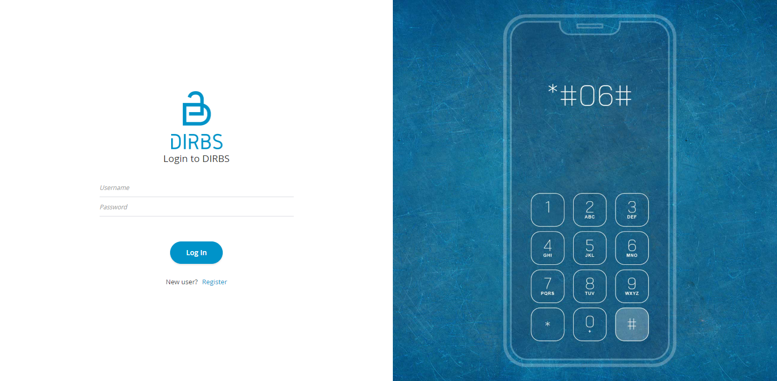

Figure 1-Login Screen

# **Dashboard Overview**

The dashboard screen is divided into following sections.

1. **Header** section displays the name of the system, name of the logged in user with logout functionality.
2. **Main Navigation Panel** helps user to navigate the system.
3. **Blocks** display over all stats of core and all subsystems of DIRBS.

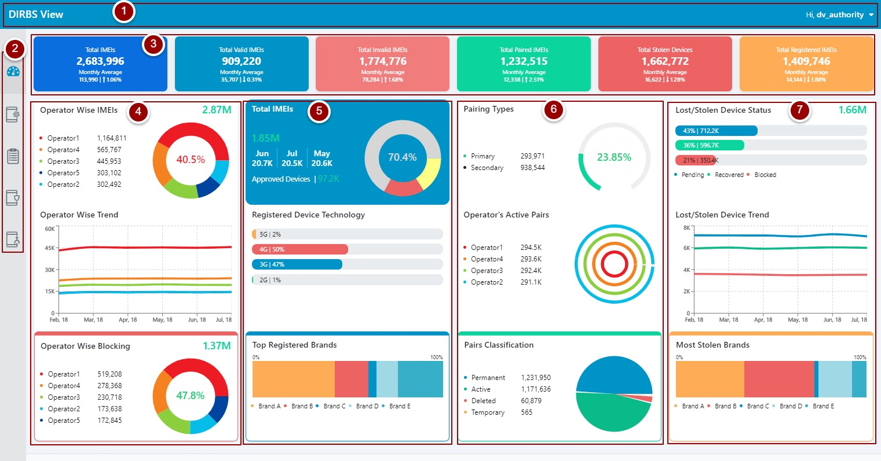

Figure 2-Dashboard Screen

1. This sectioncontains all major stats of Core.
   1. Displays total number of IMEIs in Core.
   2. This table shows count of IMEIs operator wise.
   3. This pie graph represents count of IMEIs of each operator and displays the operator having maximum number of IMEIs in percentage.
   4. This line graph shows the number of IMEIs of each operator month wise.
   5. This shows the total number of IMEIs in black list.
   6. This table shows operator wise IMEIS in black list.
   7. This pie graph represents operator wise IMEIs in black list with the percentage of black list IMEIs in Core.

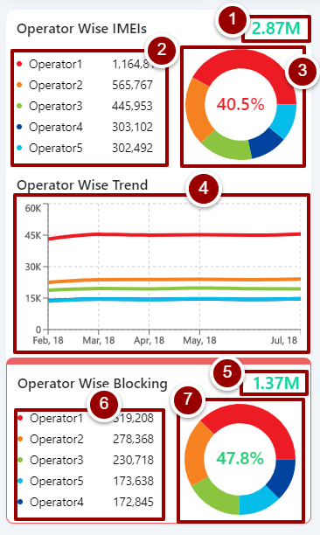

Figure 3- Core Details

1. This segmentcomprises all major stats of DRS.
   1. This shows the total number of IMEIs in DRS.
   2. This segment shows number of IMEIs in DRS month wise.
   3. This pie graph represents approved, pending and rejected IMEIs. The percentage is of approved IMEIs.
   4. This count shows the total number of approved devices.
   5. This percentage bar shows the percentage of Radio Access Technology of devices in DRS.
   6. This bar graph represents top brands in DRS.

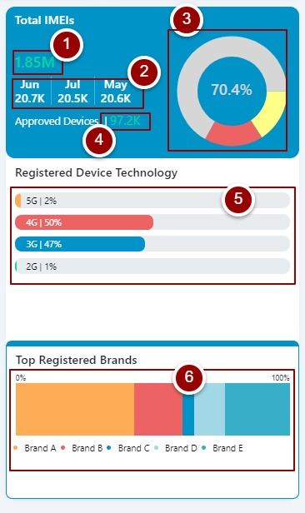

Figure 4- DRS Details

1. This fragmentholds all major stats of DPS.
   1. This section shows the number of primary and secondary pairs in DPS.
   2. This represents the percentage of primary pairs in DPS.
   3. This table shows the number of active pairs operator wise.
   4. This represents the number of active pairs operator wise.
   5. This table shows the count of pair classification i.e. permanent pairs, active pairs, deleted pairs and temporary pairs.
   6. This is the graphical representation of pair classifications.

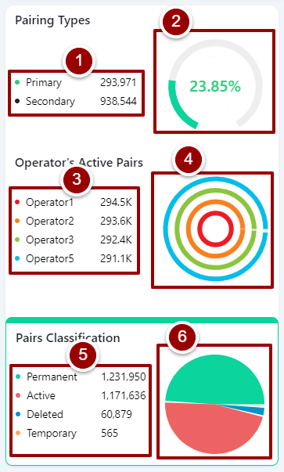

Figure 5- DPS Details

1. This segmentcovers all major stats of LSDS.
   1. This number shows the total of reported lost & stolen devices.
   2. This percentage bar shows the percentage and count of pending, recovered and blocked requests.
   3. This area graph shows the trend of blocked, pending and recovered requests month wise.
   4. This graph shows the most stolen brands.

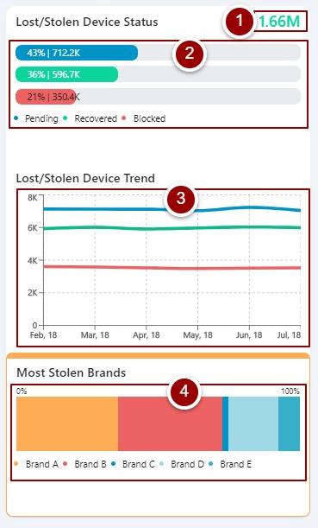

Figure 6- LSDS Details

# **Core**

To view stats related to Core click on the “Core” tab.

# **Range Graphs**

Follow below mentioned steps to view customized graphical representation of data coming from/to Core.

1. Click on “Range Graphs” under “Core” heading.
2. Select required filters.
3. Click on “Explore” button.

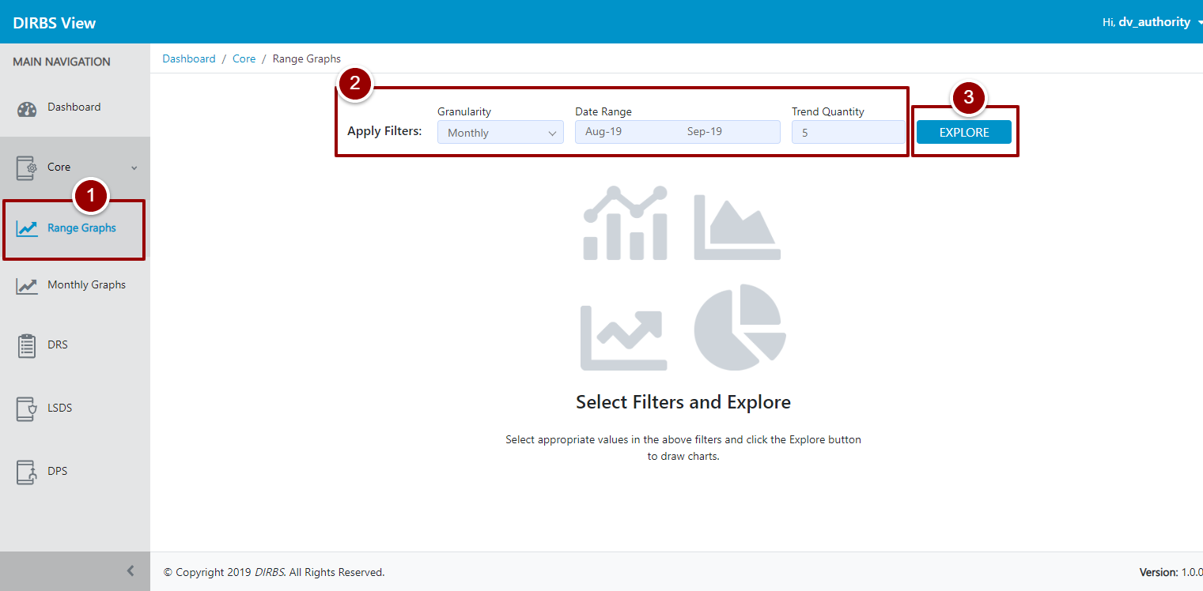

Figure 7-Range Graph

System will display stats according to the filters fixed earlier in step 2.

1. Blocks on top shows total count of unique IMEIs, Compliant IMEIs, Non-Complaint IMEIs according to data dumps of mobile operators and last three block represents count of IMEIs in Black List, IMEIs in Exception List, and IMEIs in Notification List generated by Core after classification.
2. User can change the filters by clicking on E:\Data\CACF\DIRBS Intl\DIRBS View\Screenshots\Edit icon.PNG icon.
3. This resizable stack bar graph displays number of IMEIs of top models registered during the selected time period, using registration list coming as input data to Core.
4. This table shows the details about top models w.r.t their Make, Device Type, Brand, RAT and Count in the selected time period.

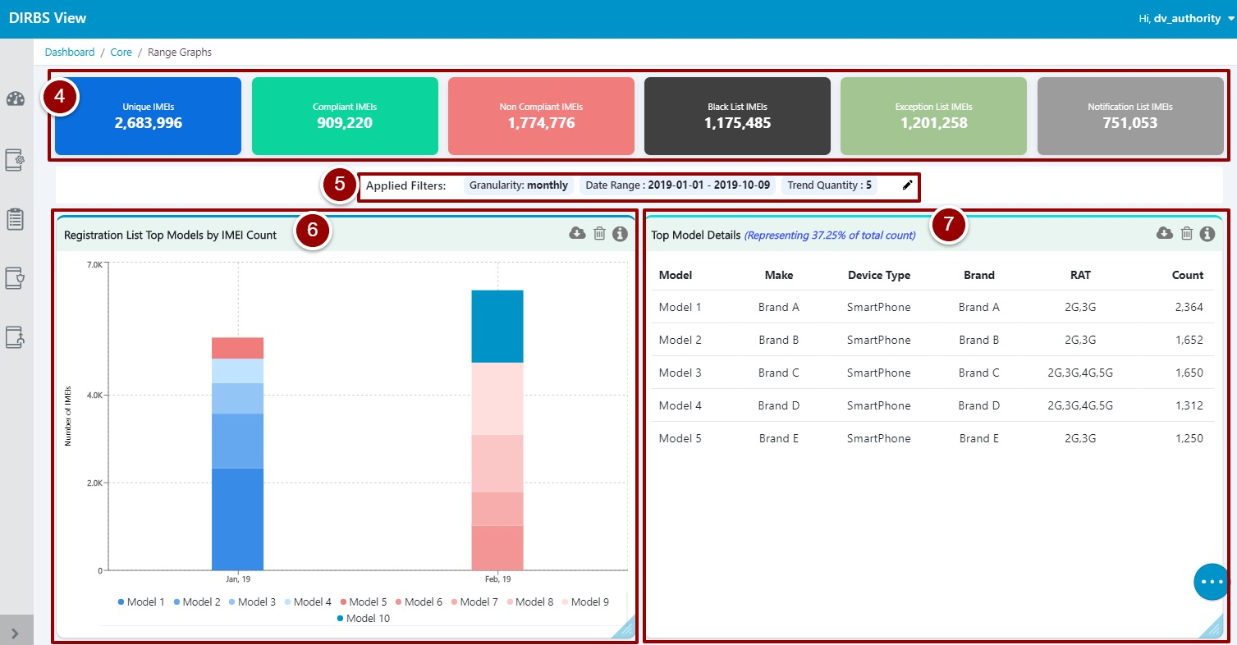

Figure 8- Top Model Details

1. This resizable line graph shows number of IMEIs in black list generated by Core after classification over the period of last 6 months.

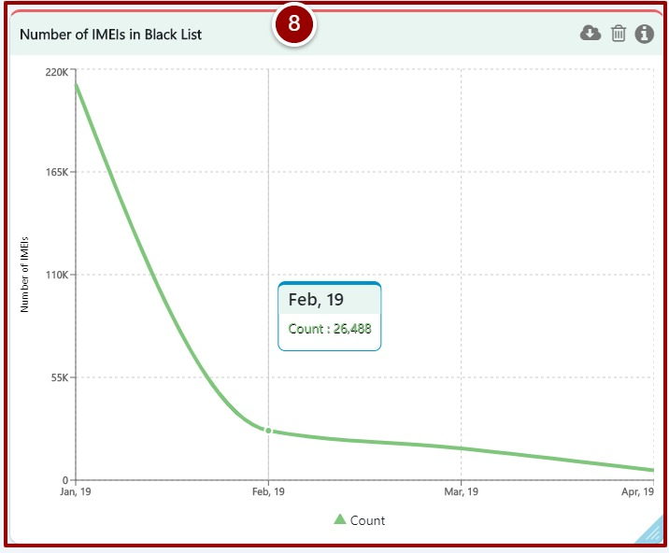

Figure 9-Number of IMEIs in Black List

1. This table shows unique IMEIs, IMSI, IMEI-IMSI pairs and total IMEIs present in Core exception list for each mobile operator over the period of last 6 months.

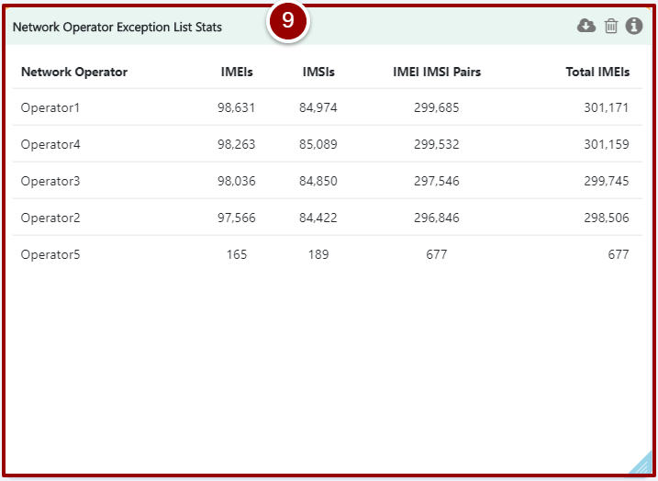

Figure 10- Network Operator Exception List Stats

1. This table shows the unique IMEI, IMSI, MSISDN count as well as pair counts of IMEI-IMSI, IMEI-MSISDN, and IMSI-MSISDN along with triplet count (IMEI-IMSI-MSISDN) and total number of IMEIs generated by Core Notification List for each mobile operator.

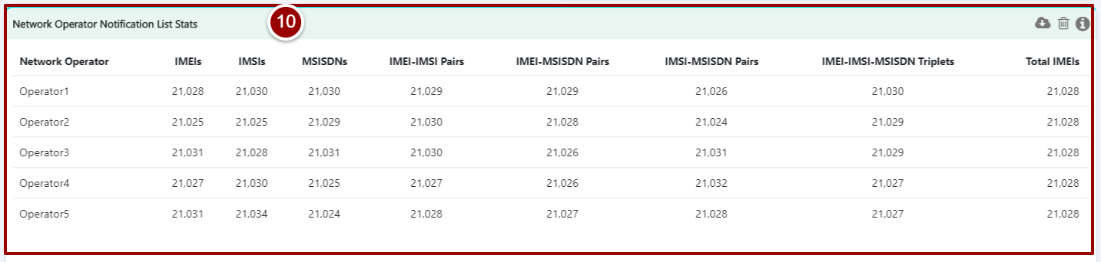

Figure 11- Network Operator Notification List Stats

# **Monthly Graphs**

Follow below mentioned steps to view customized graphical representation of data month wise coming from/to Core.

1. Click on “Monthly Graph” under “Core” heading.
2. Select required filters.
3. Click on “Explore” button.

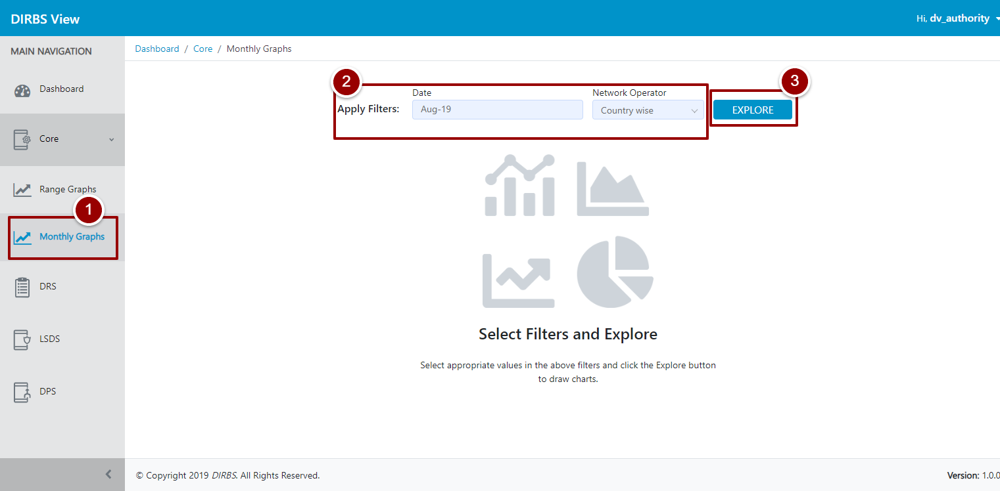

Figure 12- Monthly Graph

System will display stats according to the filters set earlier in step 2.

1. Blocks on top shows total count of Unique IMEIs, Compliant IMEIs, Non-Complaint IMEIs, Black List IMEIs, IMEIs in Exception List, and IMEIs in Notification List.
2. User can change the filters by clicking on E:\Data\CACF\DIRBS Intl\DIRBS View\Screenshots\Edit icon.PNG icon.
3. This table shows count of identifiers from data dumps i.e. Devices, Subscribers, Connections, IMEI-IMSI Pairs, IMEI-MSISDN Pairs, IMSI-MSISDN Pairs, Triplets (IMEI, IMSI, and MSISDN), and Total IMEIs of the selected month.
4. This line graph shows the trend of unique IMEIs, IMSIs and MSISDNs count over the last 6 months.

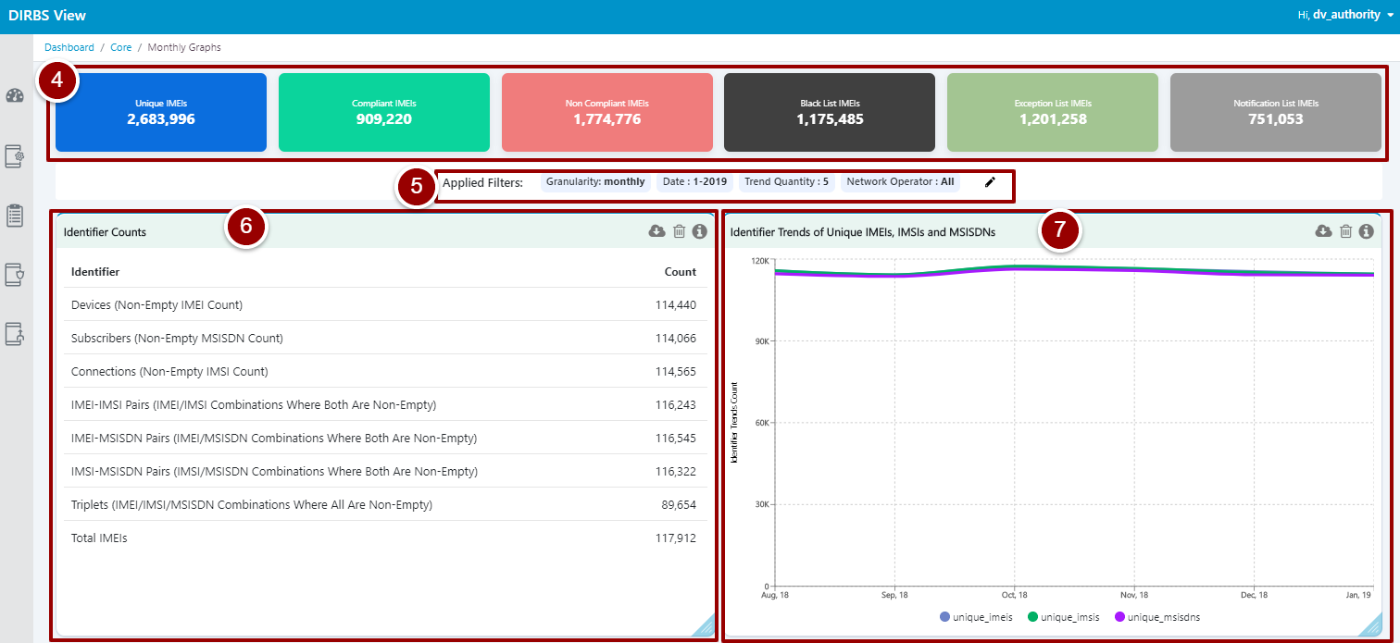

Figure 13- Identifier Counts

1. This table shows the count and percentage of compliant and non-compliant IMEIs and representation of those IMEIs in triplets as seen on network.

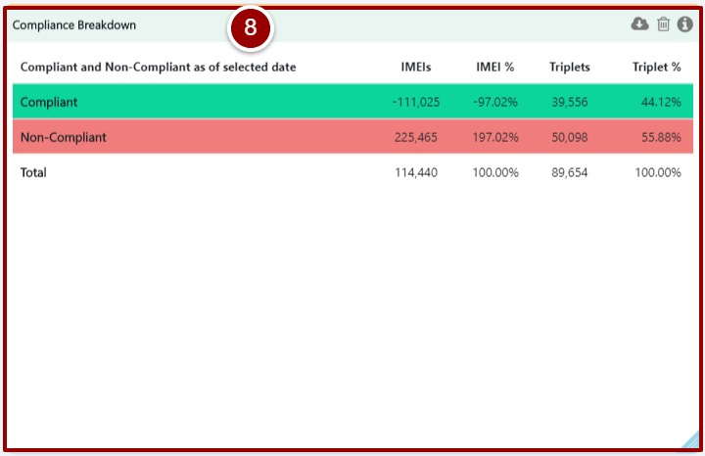

Figure 14- Compliance Breakdown

1. This line graph depicts the trend of identifiers (compliant & non-compliant IMEIs) in percentage over the last 6 months.

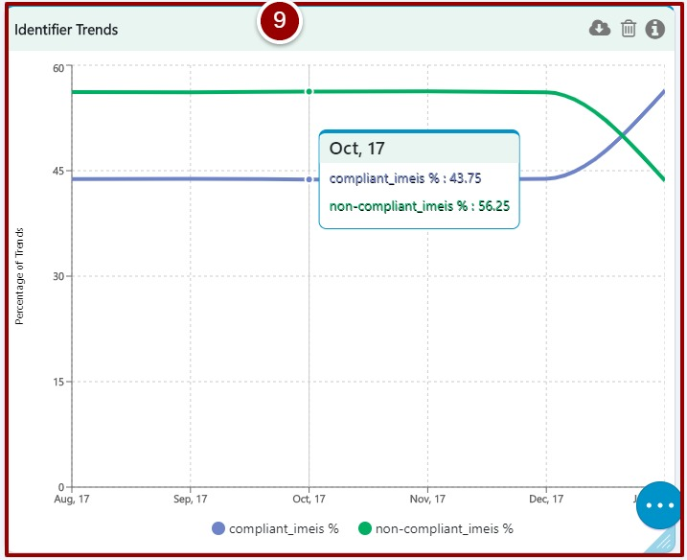

Figure 15- Identifier Trends

1. This horizontal bar graph represents the violations of blacklist IMEIs by mobile operators, this violation is segregated by number of days.

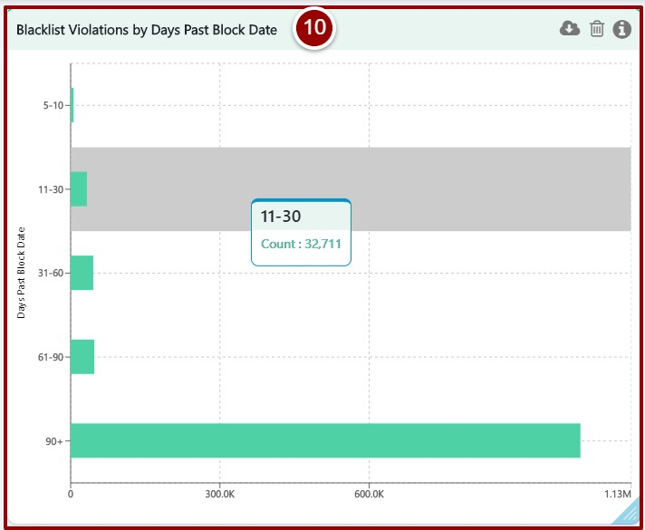

Figure 16- Blacklist Violations by Days Post Block Date

1. This doughnut chart shows the percentage of reported lost & stolen IMEIs which are seen on particular network operator.

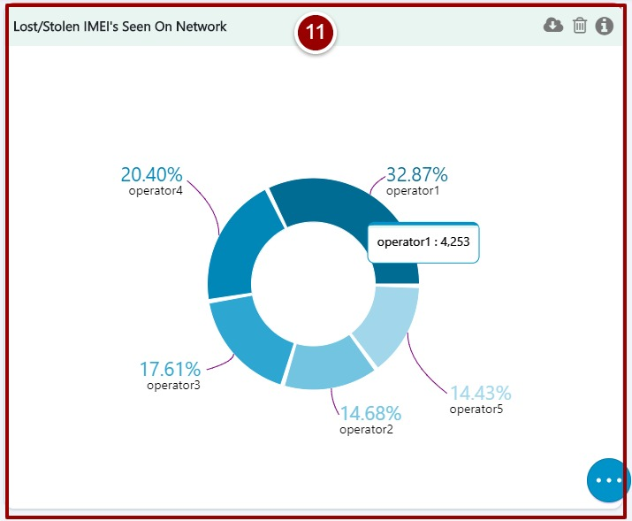

Figure 17- Lost/Stolen IMEIs Seen on Network

1. This table shows reason and count of black listed IMEIs for particular operator selected in step 2.

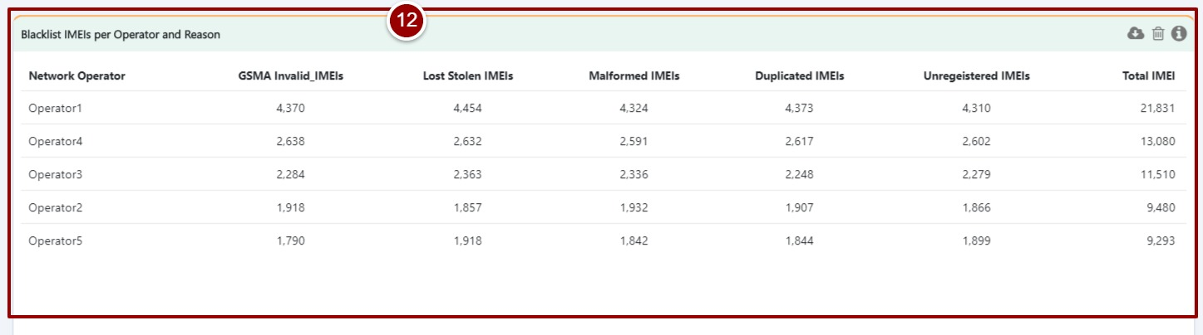

Figure 18- Blacklist IMEIs per Operator and Reason

1. This horizontal graph denote the violations of blacklist IMEIs represents in number of days by particular mobile operator selected in step 2.

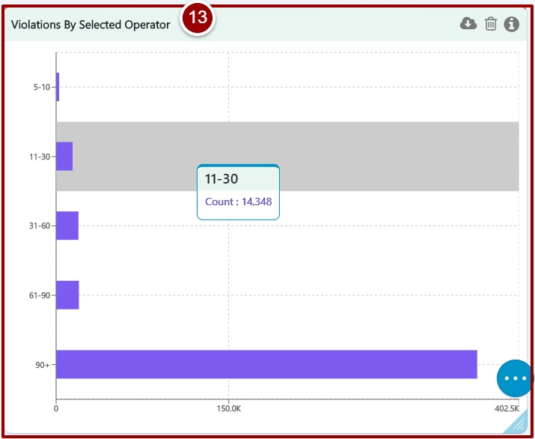

Figure 19- Violations by Selected Operator

1. This doughnut graph shows percentage of different categories of IMEIs classified in Core.

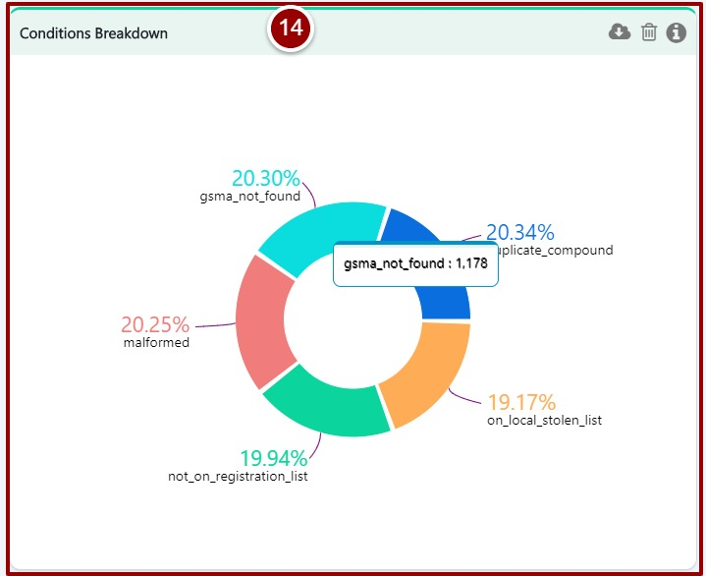

Figure 20- Conditions Breakdown

1. This table shows all the possible classification of data and their aggregated counts of IMEIs, IMEI-IMSI pairs and triplets where C1 to C5 represents classification conditions as mentioned below.
   1. **C1:** GSMA not Found
   2. **C2:** Malformed
   3. **C3:** Not of Registration List
   4. **C4:** On Local Stolen List
   5. **C5:** Duplicate Compound

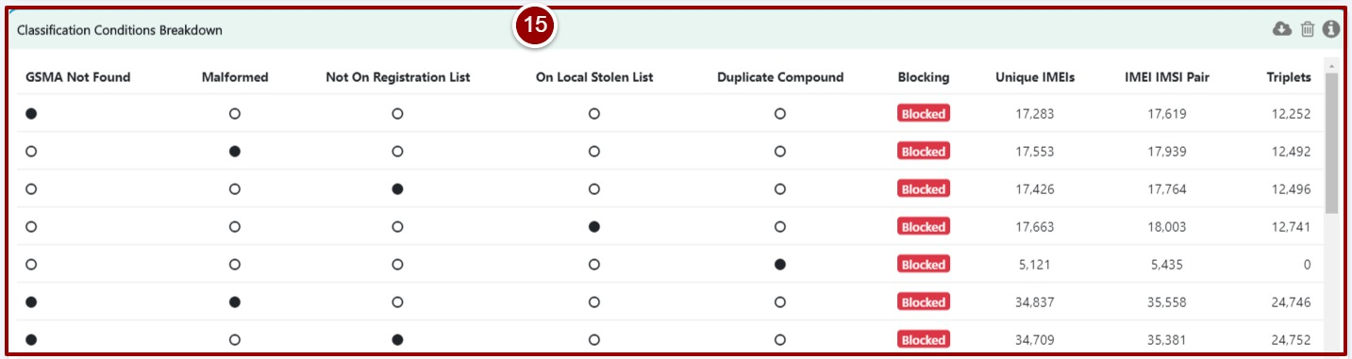

Figure 21- Classification Conditions Breakdown

# **Device Registration Subsystem**

Follow below mentioned steps.to view customized graphical representation of data coming from DRS.

1. Click on the “DRS” tab.
2. Select required filters.
3. Click on “Explore” button.

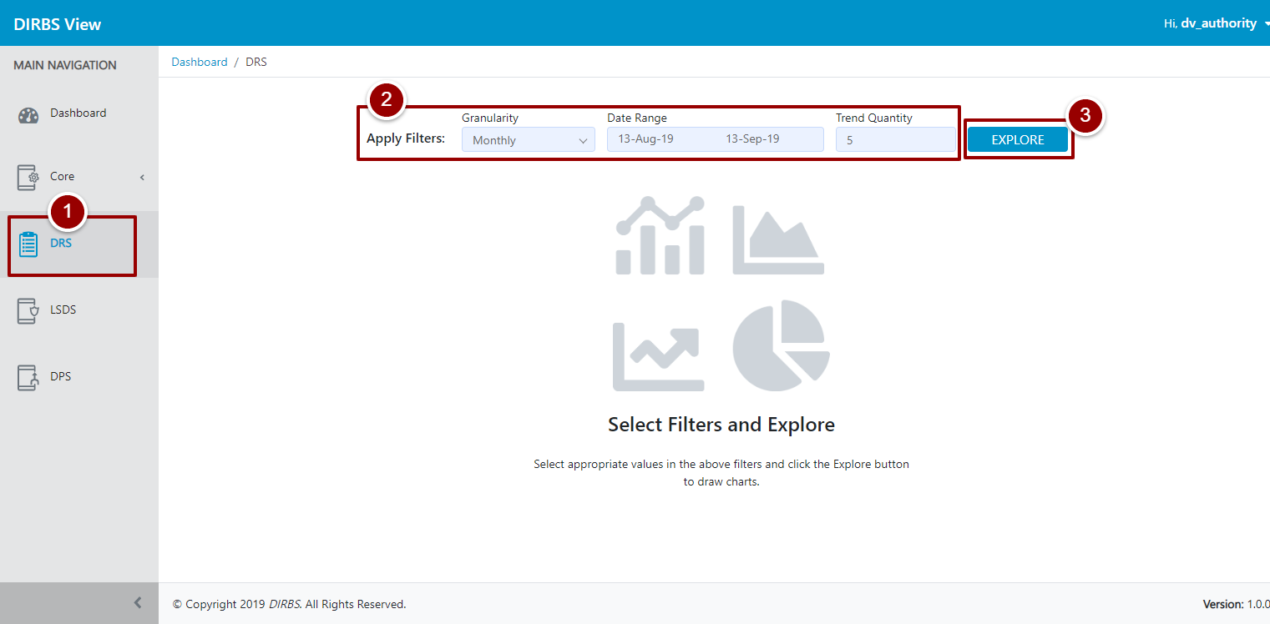

Figure 22- Device Registration Subsystem

System will display stats according to the filters set earlier in step 2.

1. Blocks on top shows total count of Registered Devices, Registered IMEIs, Rejected IMEIs, Pending IMEIs, Registered Smartphones, and Rejected Featured Phones.
2. User can change the filters by clicking on E:\Data\CACF\DIRBS Intl\DIRBS View\Screenshots\Edit icon.PNG icon.
3. This bar graph represents the number of IMEIs successfully registered by users over the period of time.
4. This stack bar graph displays the number of IMEIs w.r.t their current status in the system.

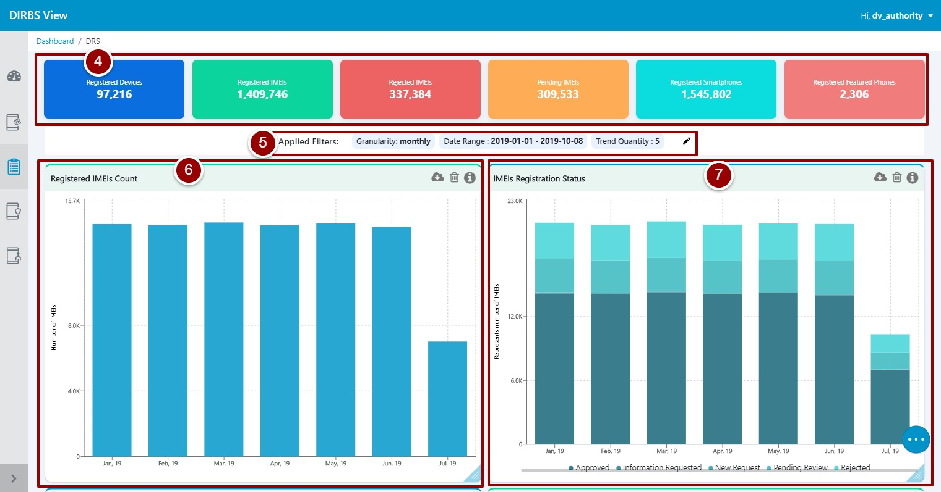

Figure 23- IMEI Registration Status

1. This stack bar graph shows the top brands registered in the system.

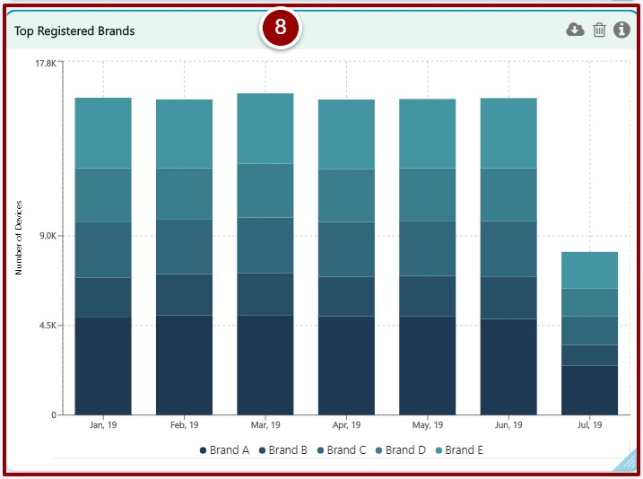

Figure 24- Top Registered Brands

1. This stack bar graph shows the top models of those brands registered by users.

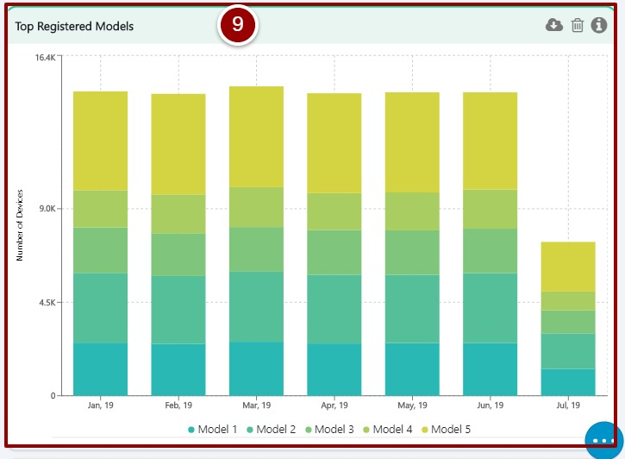

Figure 25- Top Registered Models

1. This stack bar graph shows the technology of the registered devices from 2G to 5G over the period of time.

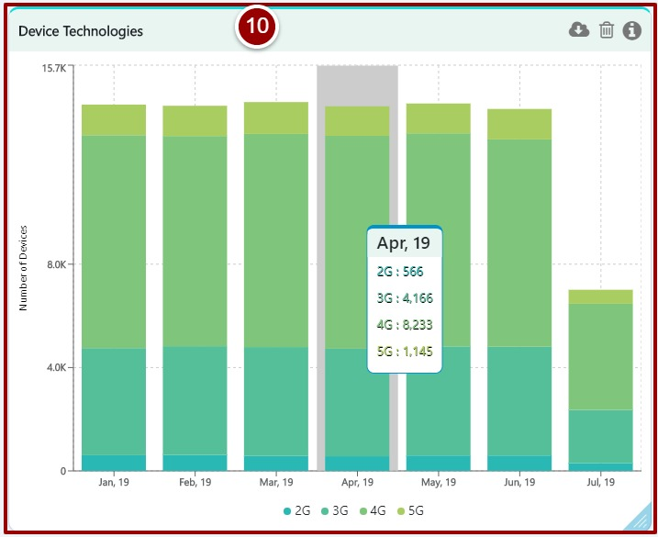

Figure 26- Device Technologies

1. This stack bar graph represents the operating system of the registered device.

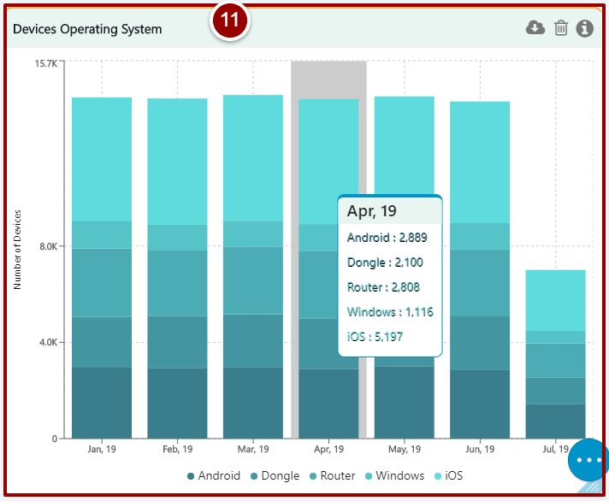

Figure 27- Device Operating System

1. This area graph displays the manufacturing location (Local, Overseas) of the registered devices.

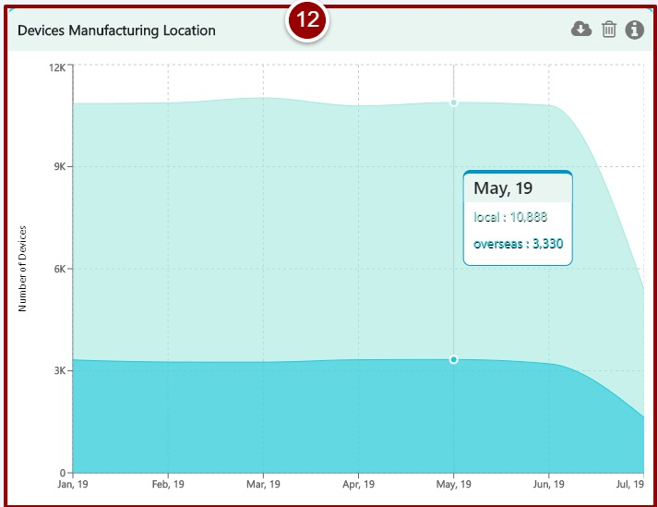

Figure 28- Device Manufacturing Location

1. This stack bar graph represents the top 5 registered device types.

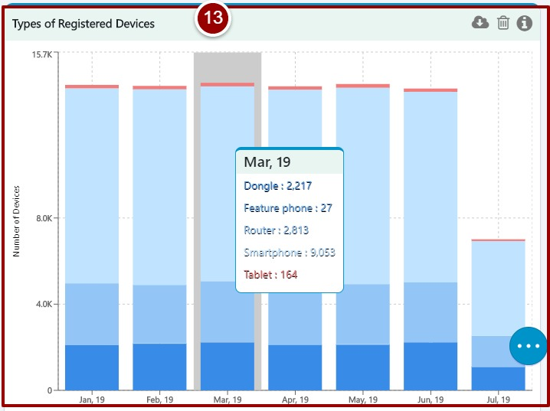

Figure 29- Types of Registered Devices

1. This doughnut graph represents the top 5 device importers who had done most numbers of registrations.

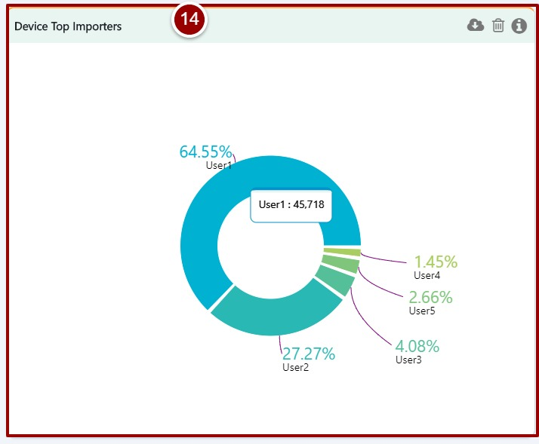

Figure 30- Device Top Importers

1. This area graph displays the count of method preferred by the user for registration in percentage over the period of time.

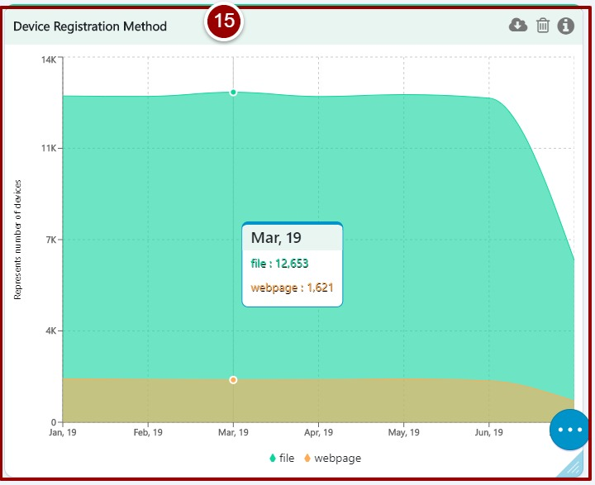

Figure 31- Device Registration Method

1. This stack bar graph represents the registered devices according to their number of IMEI slots over the period of time.

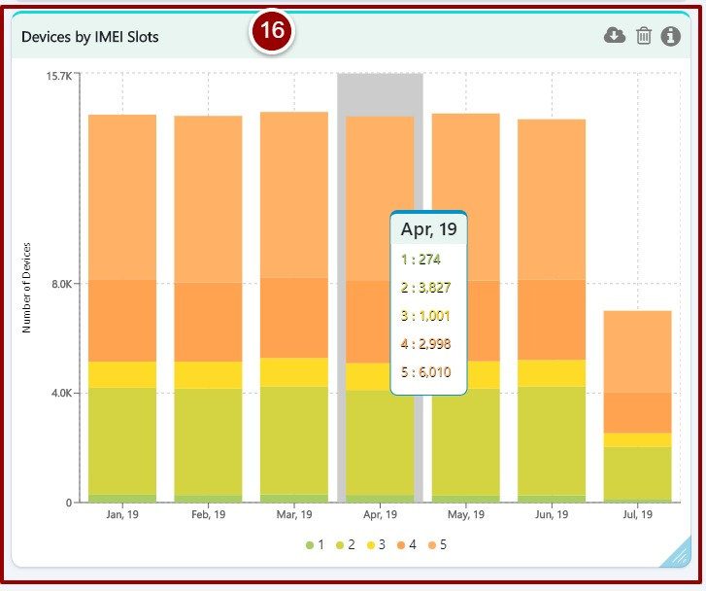

Figure 32- Devices by IMEI Slots

# **Lost & Stolen Device Subsystem**

Follow below mentioned steps to view customized graphical representation of data coming from LSDS follow below mentioned steps.

1. Click on the “LSDS” tab.
2. Select required filters.
3. Click on “Explore” button.

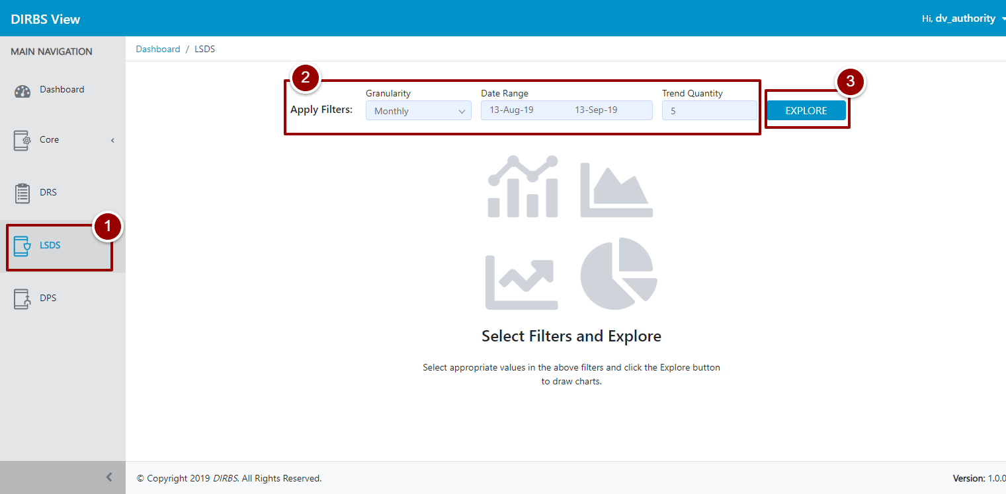

Figure 33- Lost & Stolen Device Subsystem

System will display stats according to the filters set earlier in step 2.

1. Blocks on top shows total count of Reported Devices, Stolen Devices, Lost Devices, Recovered Devices, Pending Devices and Blocked Devices.
2. User can change the filters by clicking on E:\Data\CACF\DIRBS Intl\DIRBS View\Screenshots\Edit icon.PNG icon.
3. This line graph represents the number of reported devices over the period of time.
4. This stack bar graph represents the count of top models of those brands which were reported as lost or stolen by the user(s).

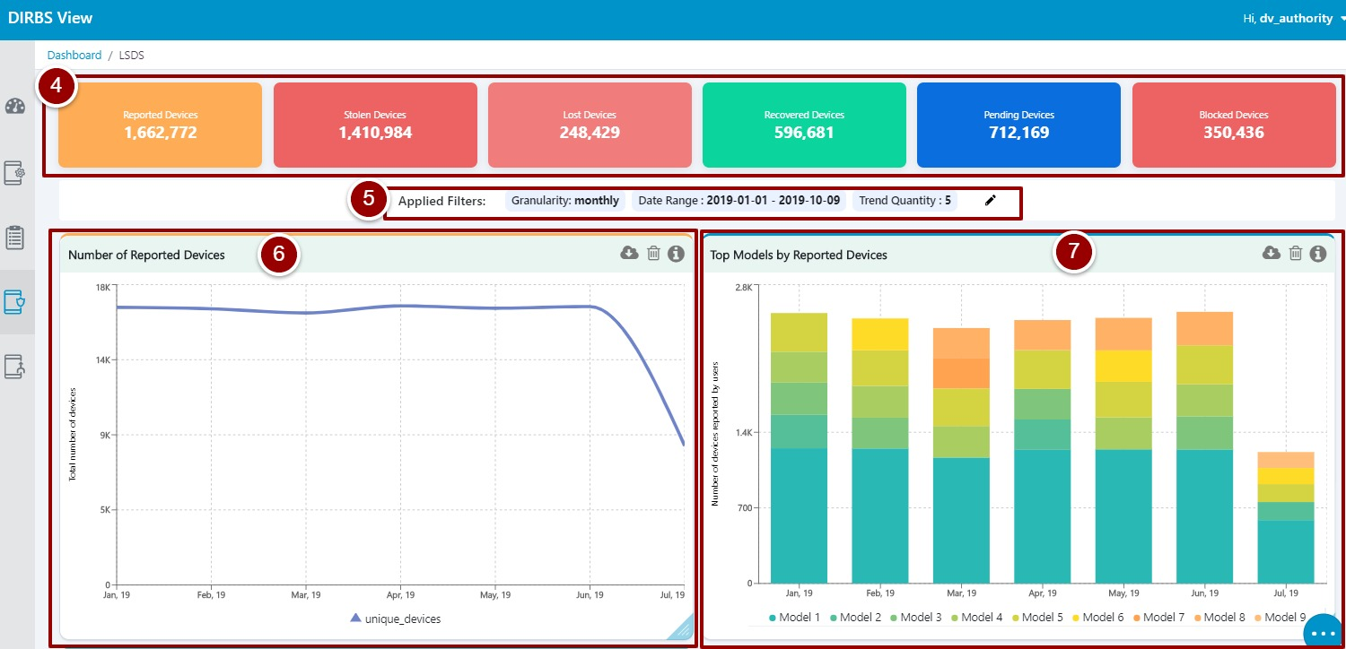

Figure 34- Status of Reported Devices

1. This stack bar graph displays the top brands of the devices reported as lost or stolen by the user(s).

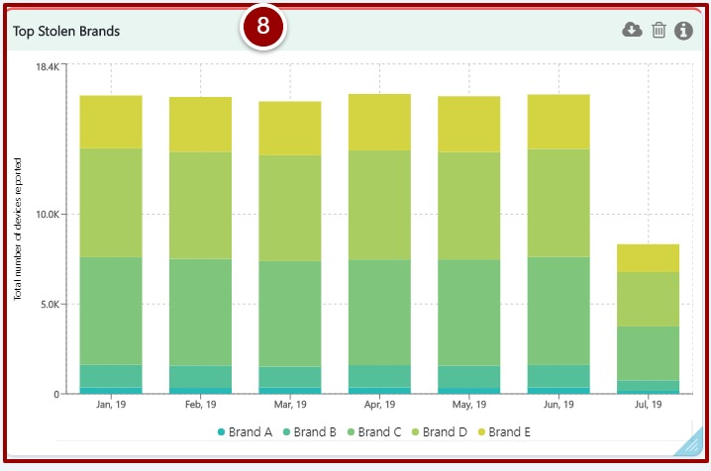

Figure 35- Top Stolen Brands

1. This stack bar graph displays the number of devices w.r.t their current status in the system over the period of time.

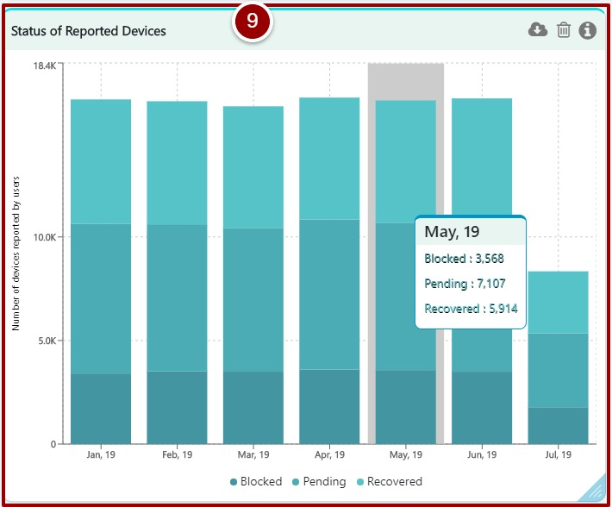

Figure 36- Top Models by Reported Devices

1. This area graph represents the count of device(s) reported as lost or stolen.

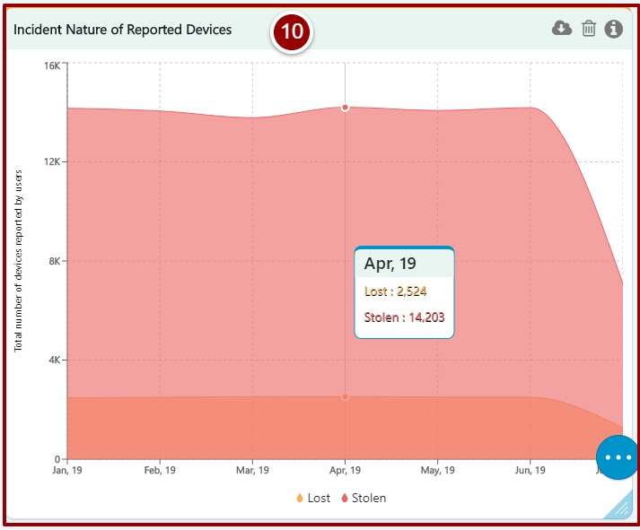

Figure 37- Incident Nature of Reported Devices

# **Device Pairing Subsystem**

Follow below mentioned steps to view customized graphical representation of data coming from DPS.

1. Click on the “DPS” tab.
2. Select required filters.
3. Click on “Explore” button.

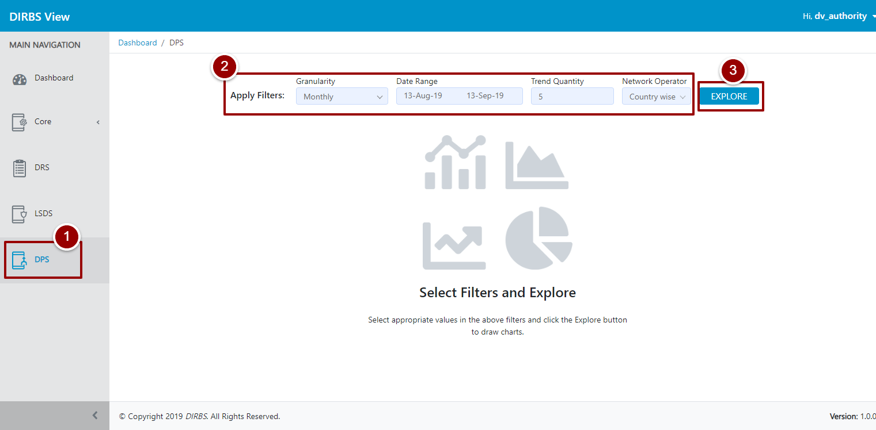

Figure 38- Device Pairing Subsystem

System will display stats according to the filters set earlier in step 2.

1. Blocks on top shows total count of Paired Devices, Paired IMEIs, Paired IMSIs, Paired MSISDNs, IMEI-IMSI Pairs and IMEI-MSISDNs Pairs in the Device Pairing Subsystem.
2. User can change the filters by clicking on E:\Data\CACF\DIRBS Intl\DIRBS View\Screenshots\Edit icon.PNG icon.
3. This line graph represents total number or permanent pairs created by the user using DPS over the period of time.
4. This line graph represents the number of devices paired by the user(s) over the period of time.

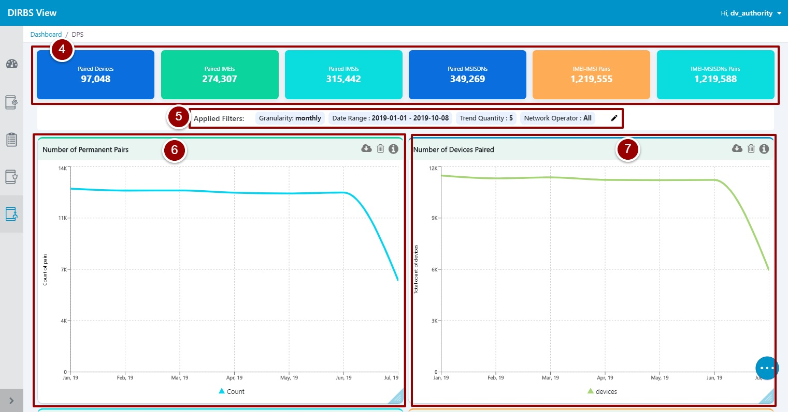

Figure 39- Number of Devices Paired

1. This stack bar graph represents the top brands of devices paired by the user(s) over the period of time.

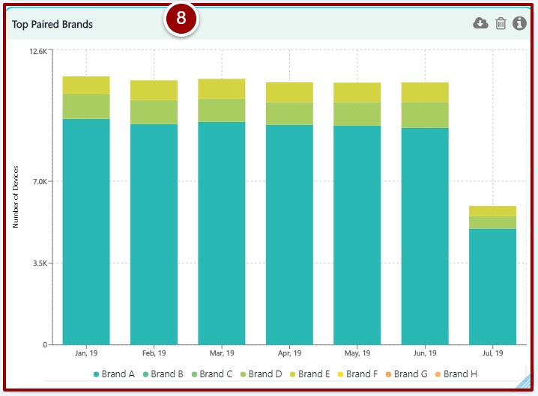

Figure 40- Top Paired Brands

1. This stack bar graph displays the top models of above mentioned top brands paired by the user(s) over the period of time.

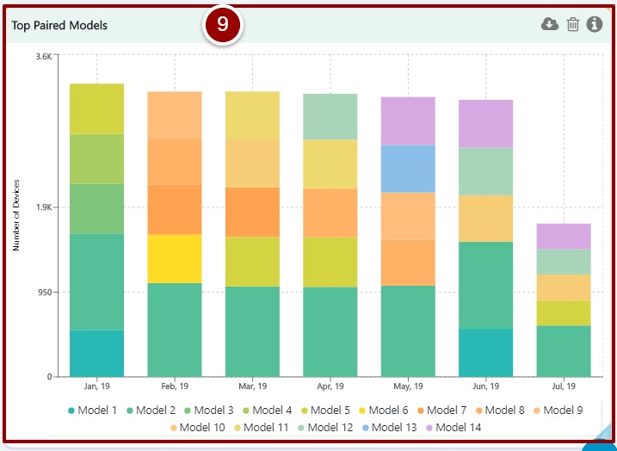

Figure 41- Top Paired Models

1. This parallel bar graph displays the active pairs (Primary and Secondary) created over the period of time.

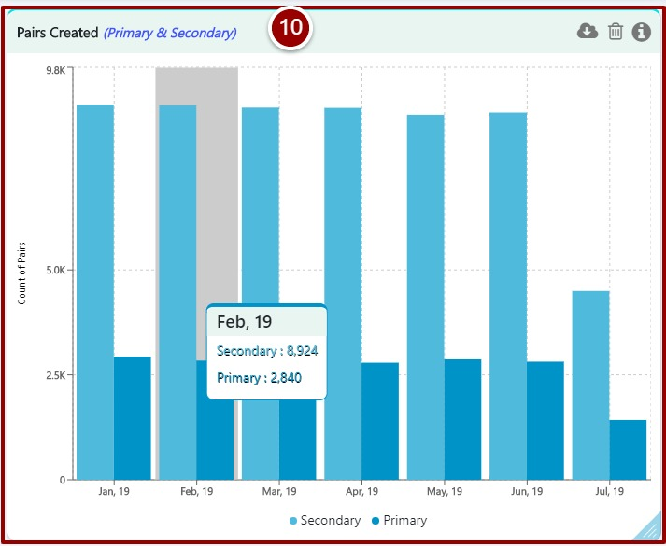

Figure 42- Pairs Created

1. This parallel bar graph displays the active pairs (Primary and Secondary) deleted over the period of time.

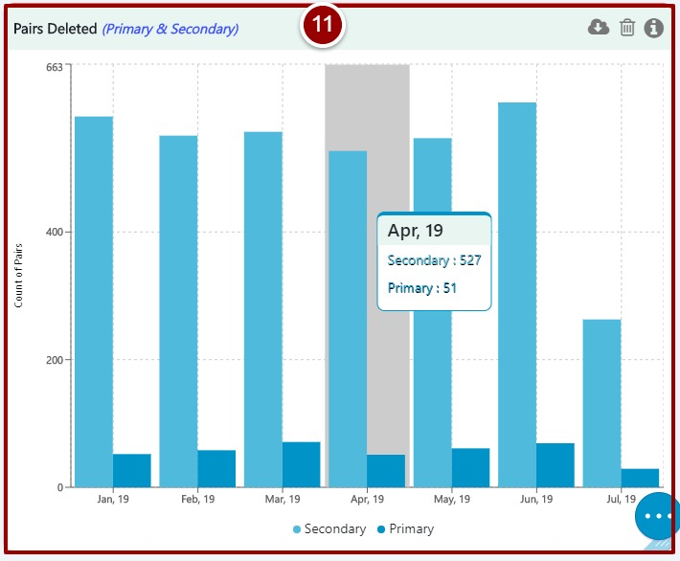

Figure 43- Pairs Deleted

1. This stack bar graph displays the radio access technology of the paired devices over the period of time.

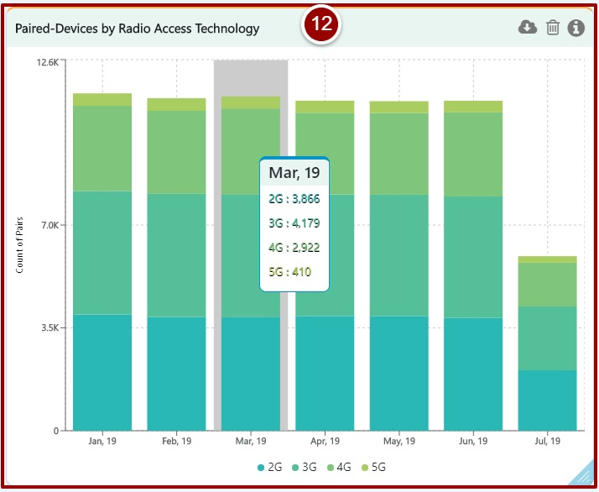

Figure 44- Paired- Devices by Radio Access Technology

1. This parallel bar graph represents the SIM change observations of connections (MSISDNs) w.r.t subscribers (IMSIs).

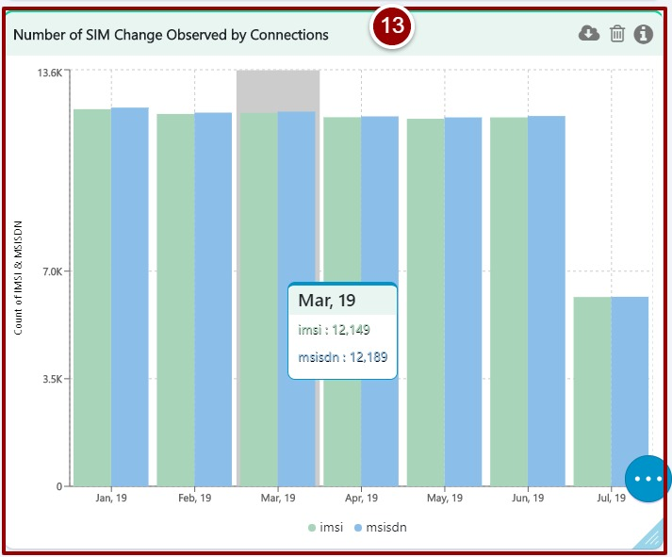

Figure 45- Number of SIM Change Observed by Connections

1. This table shows count of all-important identifiers i.e. IMEIs, IMSIs, MSISDNs, IMEI-IMSI Pair, IMEI-MSISDN Pair, IMSI-MSISDN Pair, Triplet for each operator.

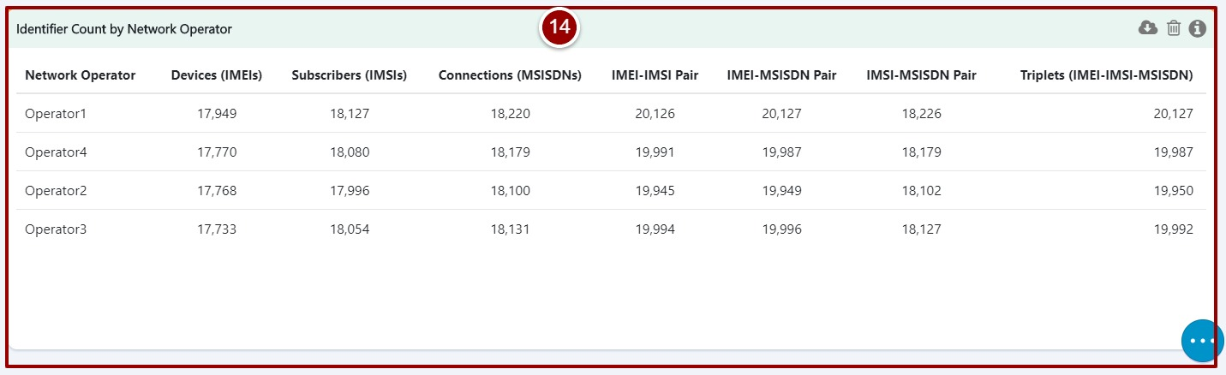

Figure 46- Identifier Count by Network Operator